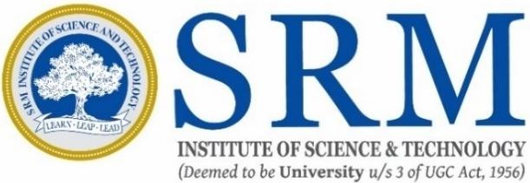
21IPC501J RESEARCH METHODOLGY

LABORATORY EXERCISE REPORT
(Academic Year: 2025-2026)

NAME
REGISTER NUMBER
: Goutham G
: RA2512053010001
YEAR : I
SEMESTER : I

DEPARTMENT OF ELECTRONICS & INSTRUMENTATION ENGINEERING COLLEGE OF ENGINEERING AND TECHNOLOGY
SRM INSTITUTE OF SCIENCE AND TECHNOLOGY KATTANKULATHUR-603203

SRM INSTITUTE OF SCIENCE & TECHNOLOGY
(under Section 3 of UGC Act, 1956)
SRM NAGAR, KATTANKULATHUR CHENGALPATTU DISTRICT-603 203

BONAFIDE CERTIFICATE

Register No : RA2512053010001

Certified to be the bonafide record of work done by Goutham G of A&R
M. Tech Degree course in the Practical 21IPC501J – Research Methodology in SRMIST, Kattankulathur during the academic year 2025-2026

Date: Course Coordinator

INDEX

S.NO | D.O.E | Name of the Exercise | Marks | Signature
1 | 26/08/25 | Types of Research
2 | 03/09/25 | Broad Question Design
3 | 11/09/25 | Reference Organizer using Mendeley
4 | 06/10/25 | Referencing in different style
5 | 14/10/25 | Project Proposal
6 | 10/11/25 | Publication ethics and misconducts
7 | 18/11/25 | Plagiarism checking and rectification
8 | 18/11/25 | Design of Experiments and Data Analysis

